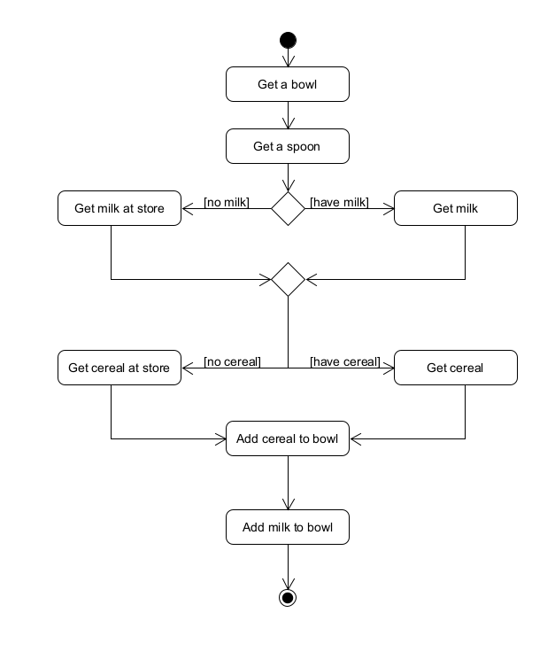1.

Get a bowl

Get a spoon

If we have milk

Get milk

Otherwise

Get milk at store

If we have cereal

Get cereal

Otherwise

Get cereal at store

Add cereal to bowl

Add milk to bowl

2.

Get a bowl

Get a spoon

If we have milk and cereal

Get milk and cereal

Otherwise If we have milk

Get cereal at store

Get milk

Otherwise If we have cereal

Get milk at store

Get cereal

Otherwise

Get cereal and milk at store

Add cereal to bowl

Add milk to bowl